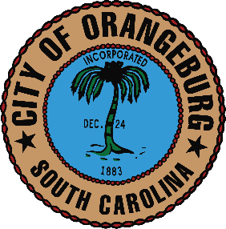

Request for Proposal of Qualifications, Design Skills – Pylon Sign and Creative Services at The North Road Complex

The City of Orangeburg is soliciting sealed proposals from qualified sign firms for a pylon entrance sign design and /or construction of the North Road Ballfield Complex located at 224 Magnolia Village Parkway. We are also looking for a proposal for creative services for wayfinding and secondary entrance signage.
The firm shall provide a unique original design for the complex that they think will best fit the ballfields as well as being a pylon sign for the businesses that will locate on parcels owned by a private developer. The sign will be paid for by one entity.

The pylon sign will need to incorporate the following:
- A custom look that is unique for the name of the area. (One theme to work with is something with Magnolia in it). The City may look at other names also.
- It will need to highlight the ballfield main entrance.
- It must have cabinet panels that will accommodate tenant space. This sign is to illuminate at night.
- In a separate quote the created sign needs to be able to accommodate a full color LED message center as part of the pylon sign. This may be a part of initial construction or added later. This will be part of your custom proposal as to how it fits in the main sign. Some may have reason to choose a certain size LED sign over others and we want you to make this a unique part of the design as well as a justification for the size recommended.
- We would like a price of what it would cost to design and bid the designed sign out or provide the reason why your company should receive the award for the sign without bidding the sign construction out. We understand creativity may sometime restrict bidding the project out as well as justification of the materials that you will use, and that others may bid inferior materials. The basis of this will be at the sole discretion of the City.
- The creative services for wayfinding and other signage will be considered in the Pylon design submitted. We are looking for signage that is unique and will highlight this premier site.

The City will reserve the right to either award on creativity for the sign/signs and the material justifications or require plans to use for bidding and construction.
We are asking you to specify if you will release the plans for a design fee or that you feel that the quality of your design would be adversely affected if it was bid out. If you are not selected and indicate your design is not able to be paid for as a design fee, it will not be shared to other bidders, and you may not be considered at this point.
A mandatory site meeting will be held on June 22, 2021 @1:00pm at the site entrance across from Lowes (alternate rain day June 24@1:00)
Sealed Qualification Proposals will be due July 13, 2021 @ 3:00pm.
For any questions, please contact Assistant City Administrator, John Singh by email at jsingh@orangeburg.sc.us or by phone 803-533-6000.
The City of Orangeburg reserves the right to accept or reject any and all proposals as the interest of the City may require and waive any formalities in the request for proposals and to award the contract in whole or in part to the most qualified responsible bidder.
References are required with examples of successfully completed work. Your references should clearly reflect timely completion of work. The inability to show a timely response and completion will be a major factor in the award of the design and /or the project.
The City of Orangeburg is an Equal Opportunity Employer.

